Weatherly – 2-Page Project Summary
Programming II Final Project | JavaFX Weather Application
Student Name: MHD Muhannad Alshatti | Student ID: 25120102062
Project Name: Weatherly | Course: Programming II
GitHub: https://github.com/muhannad2000/Weatherly | Technologies: Java, JavaFX, Maven, APIs

Project Overview
Weatherly is a JavaFX desktop weather application that allows users to register, log in, and search for real-time weather information by city name. The application displays temperature and wind speed, changes the background based on temperature, and includes an animated wind fan whose speed changes according to wind speed. It also supports optional current location detection using the user’s internet connection/IP address.
Main Features
• User registration, login, and logout.
• Local file processing using users.txt.
• Live weather search using Open-Meteo API.
• Dynamic background images for very cold, cold, chilly, and hot weather.
• Animated wind fan controlled by wind speed.
• Optional IP-based current location detection.
• Error handling for invalid city names.
Screens Preview
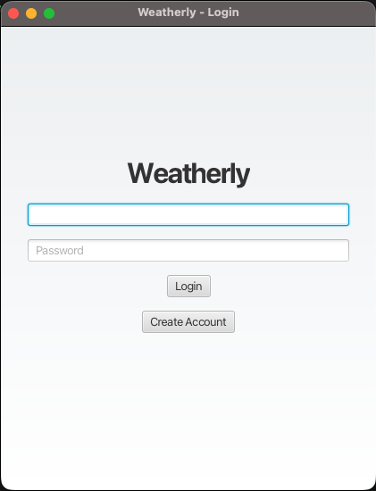 | 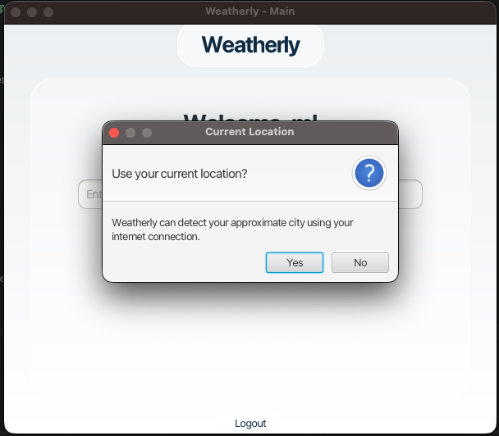
Login screen | Current location alert

Weatherly – Application Results
Dynamic weather backgrounds, live data, and error handling
Weather Examples
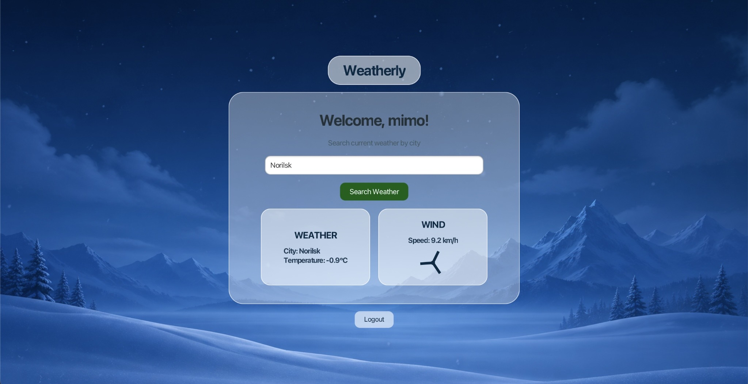  Very cold result: Norilsk | 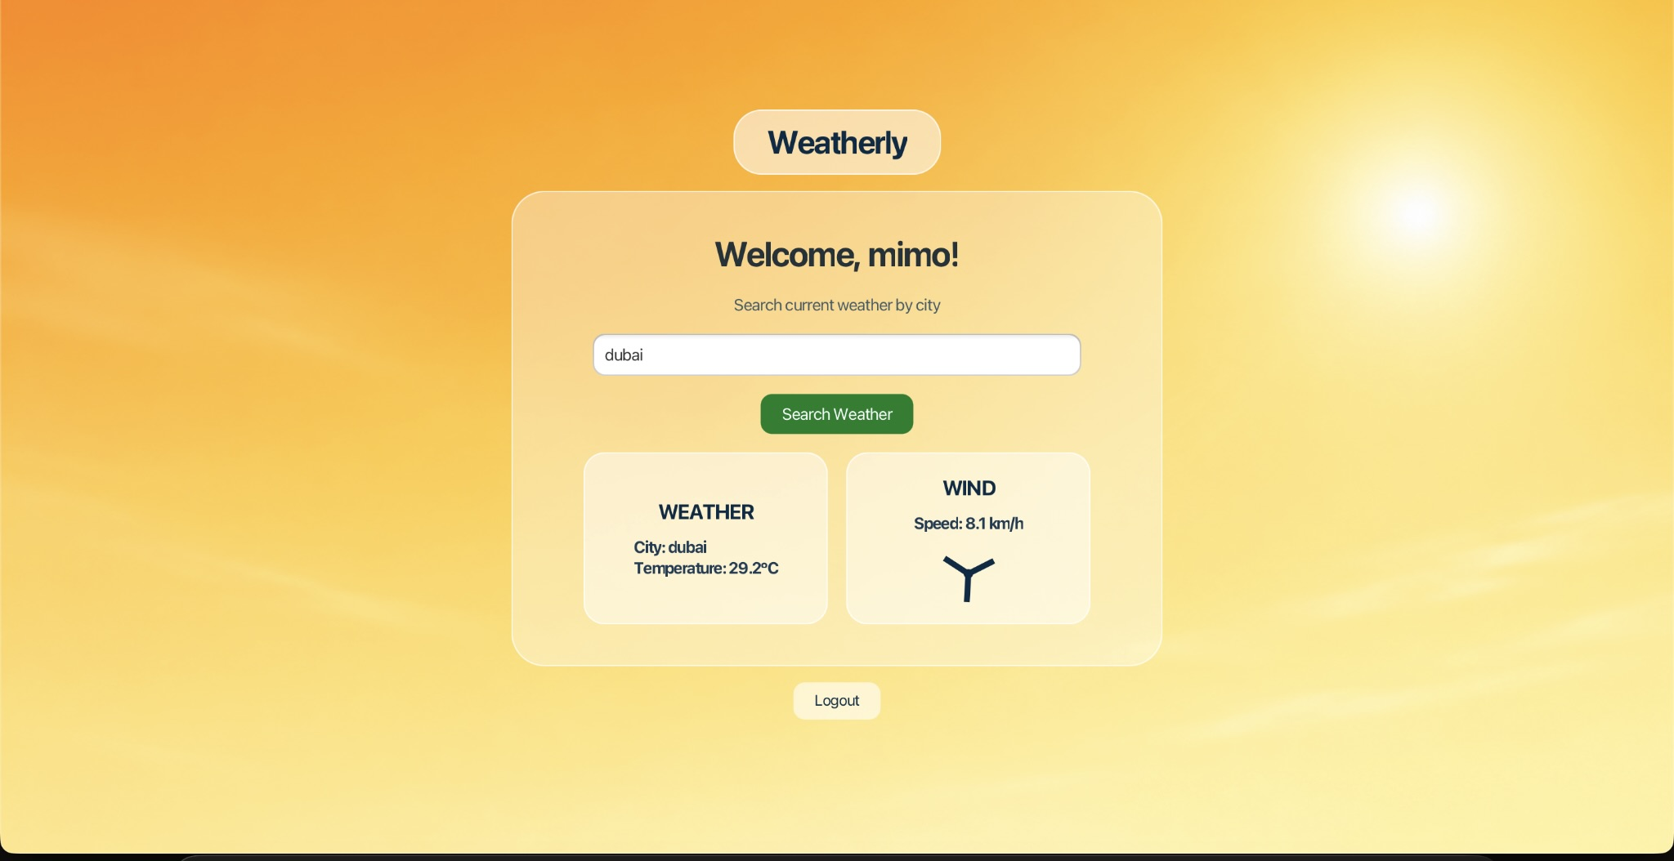  Hot result: Dubai
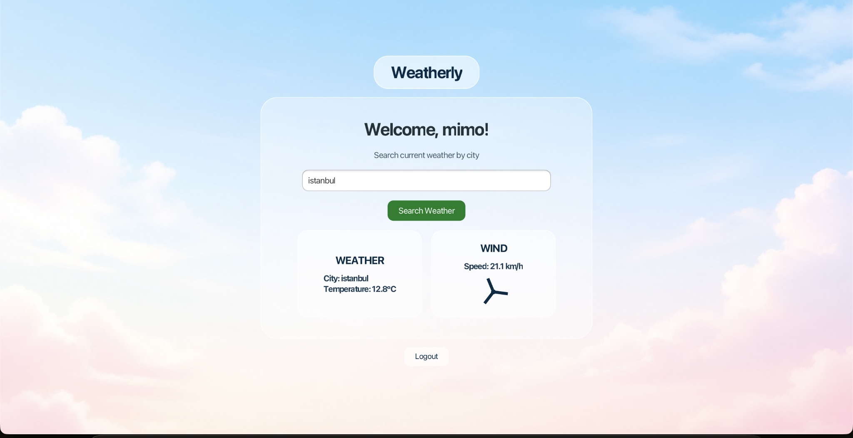  Chilly result: Istanbul | 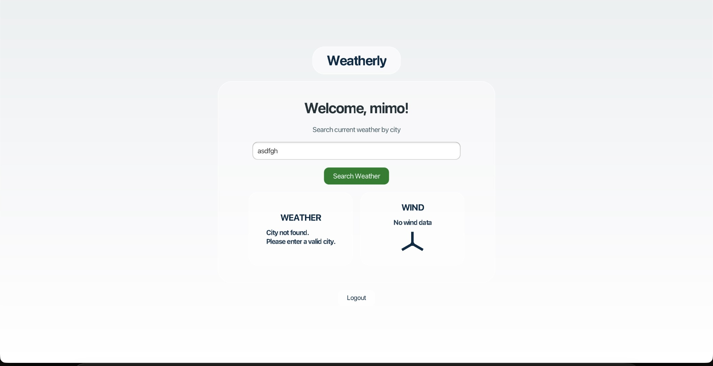  Invalid city handling

Implementation Summary
Main.java  Builds the JavaFX screens, handles events, animations, backgrounds, and current location alert. | WeatherService.java  Connects to APIs, converts city names to coordinates, and returns temperature and wind speed. | users.txt  Stores registered users locally and is read during login verification.

Conclusion
Weatherly meets the Programming II project requirements by combining JavaFX GUI design, authentication, local file processing, live API communication, animation, and a clear user interface. The project is uploaded to GitHub with a README and can be run from IntelliJ using the JavaFX Maven plugin.
GitHub Repository: https://github.com/muhannad2000/Weatherly

